AMD - sdk
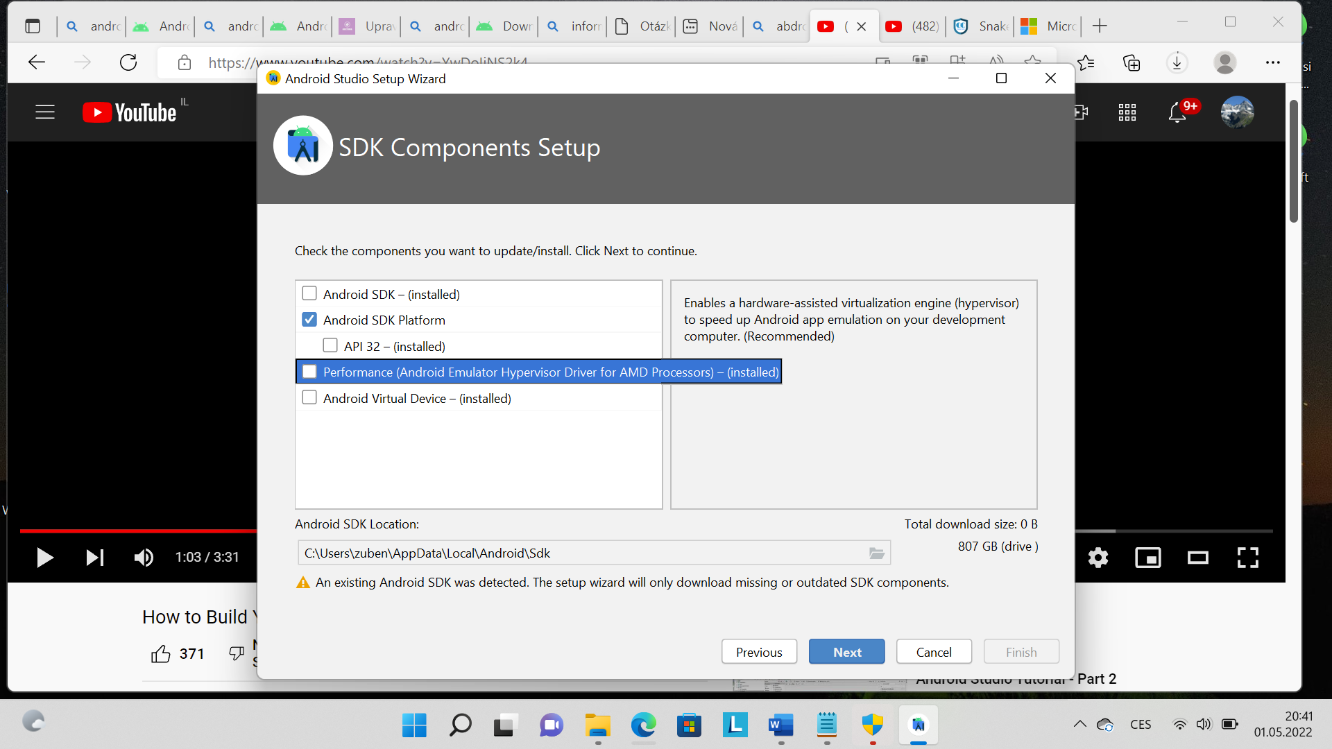
Počkat než se donwloadují další komponenty
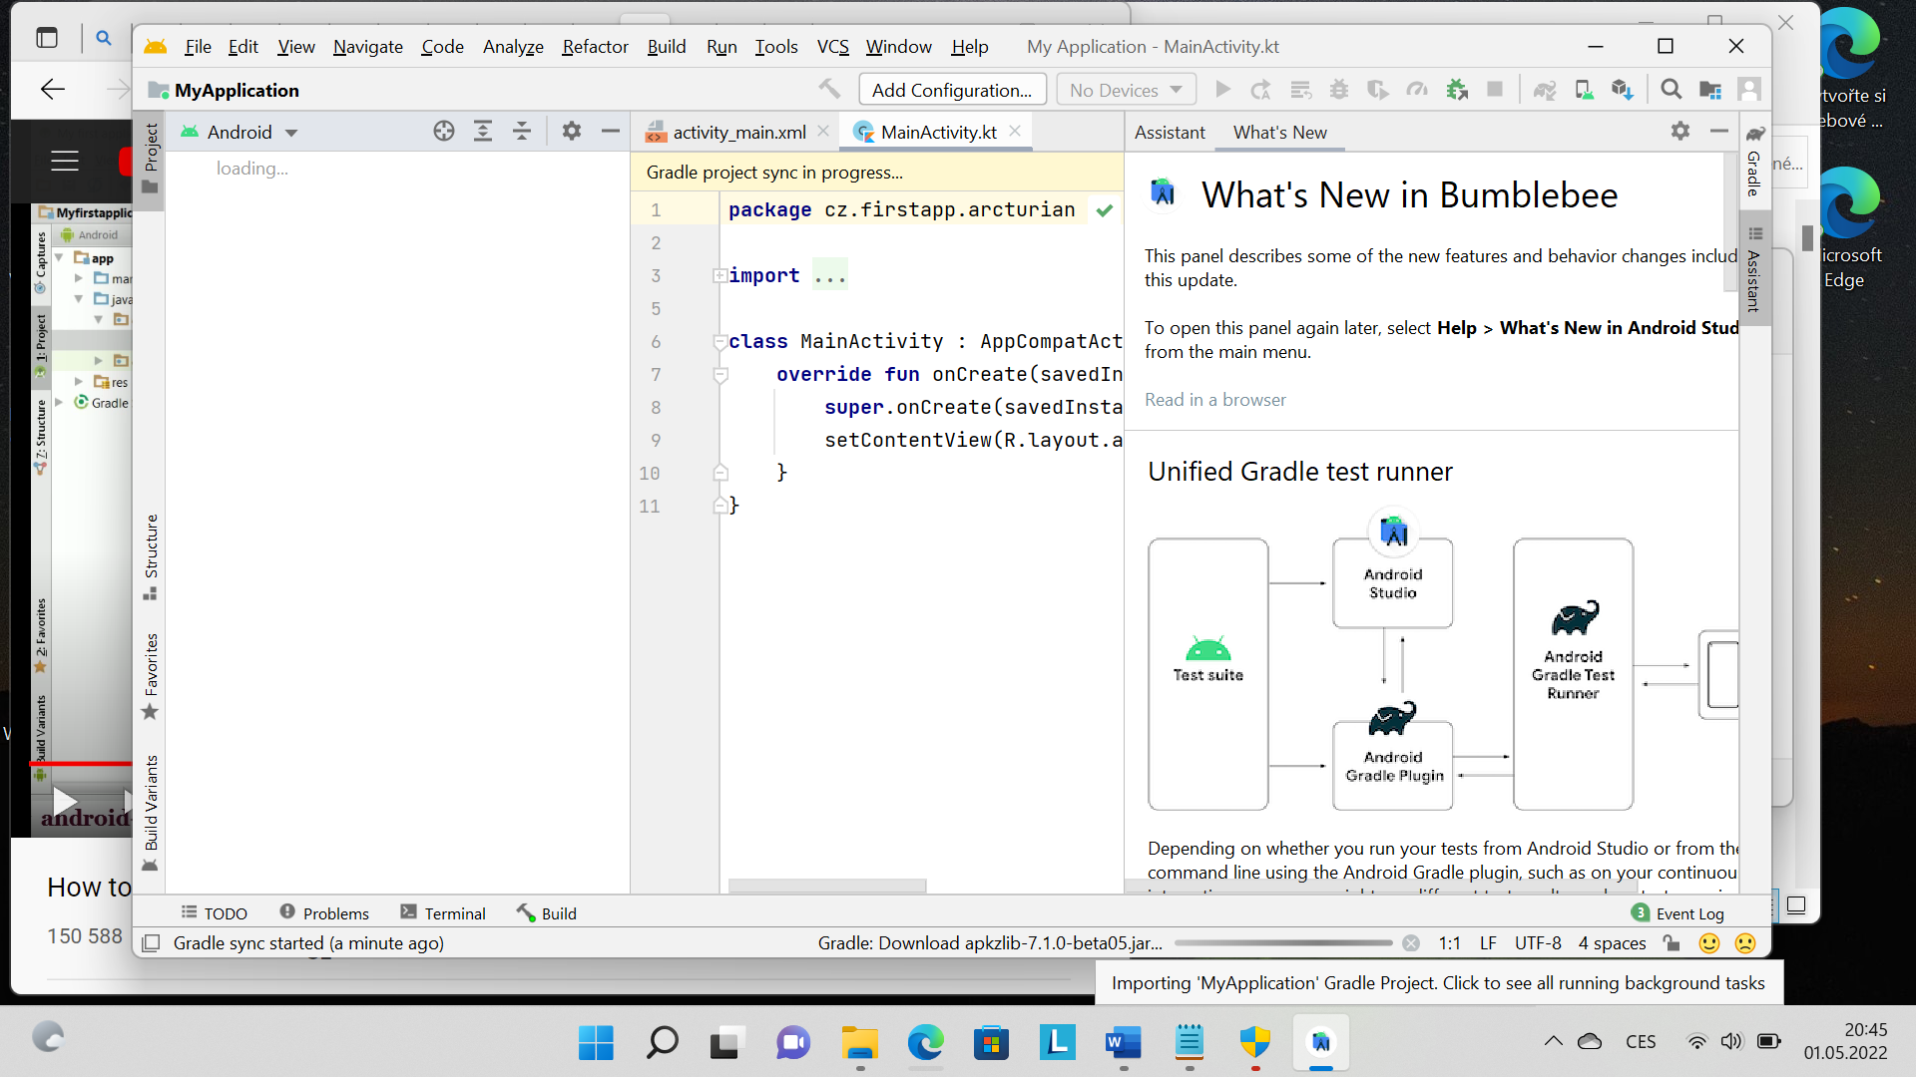
Until you get this:
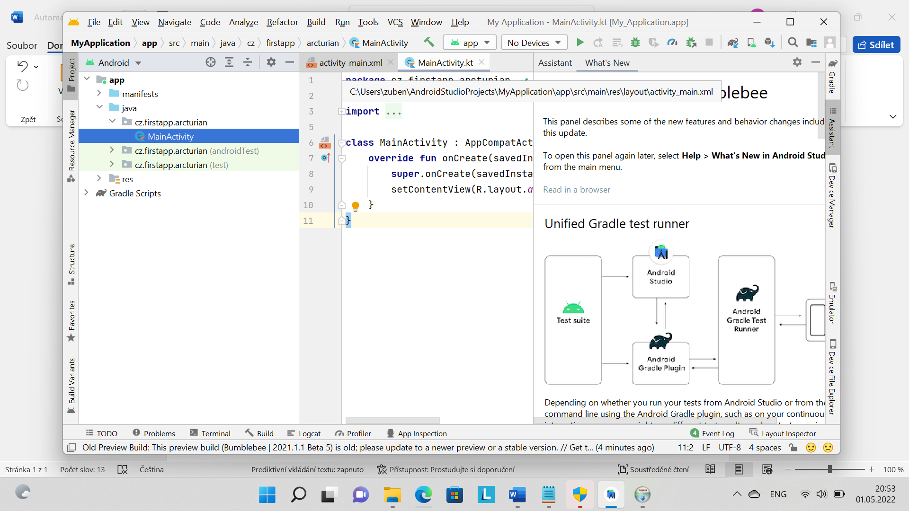

Click on activity main
Layout res aktivity main
Settings build aktivity manager 7x
Tools AVD Manager
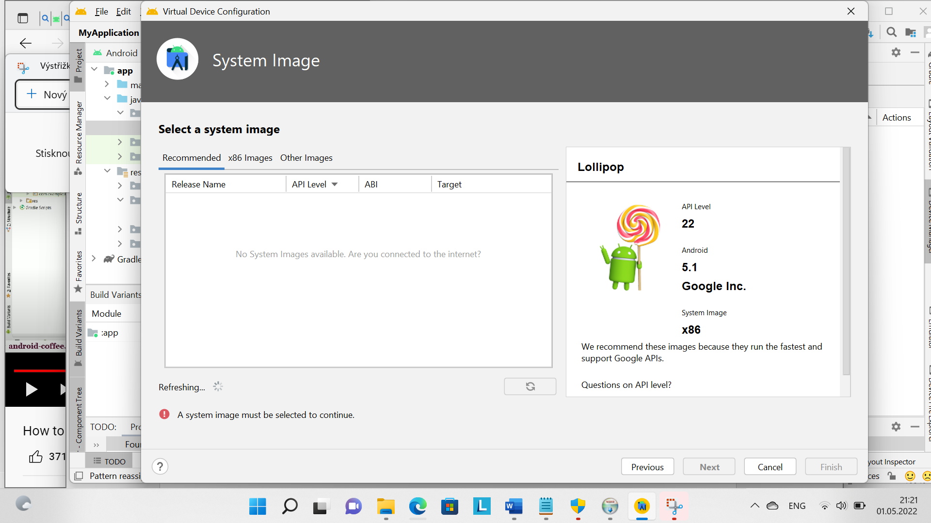

Run button emulator>

Run current app
.
Hello world app.

Instead of using an emulator you can plug in your phone and ckucj in setting, device, phone 9 times to enable developer`s mode

///
Code example> Snake Game App In Android Studio Source Code | Free Source Code (campcodes.com)

